

SKILL WORKBOOK

24SDCS02 / 24SDCS02E / 24SDCS02P / 24SDCS02L FULL STACK APPLICATION DEVELOPMENT




SKILL WORKBOOK
24SDCS02 / 24SDCS02E / 24SDCS02P / 24SDCS02L - FSAD

STUDENT NAME | Manan Shah
STUDENT ID | 2400090137
YEAR | 2nd Year
SEMESTER | 2nd Semester
SECTION | S-52
FACULTY NAME | Sridevi Sakhamuri

DEPARTMENT OF CSE, CS&IT, AI&DS
COURSE CODE: 24SDCS02 / 24SDCS02E / 24SDCS02P / 24SDCS02L FULL STACK APPLICATION DEVELOPMENT
Date of the Session: 01/01/2026 Time of The Session: to

#SKILL - 1 ➔ Git Version Control

Prerequisites:
- Basic knowledge of Git commands
- Ability to create and edit project files
- Understanding of version control basics

The development team wants to manage their project using Git to maintain a structured and collaborative workflow. In this lab, you will simulate a real-world version control process: creating project files, tracking and committing changes, using GitHub as remote storage, working with multiple branches, and handling merge conflicts. This helps you understand how developers work together efficiently in software projects.

Tasks:

- Create a new project folder, initialize Git using git init, and configure Git with your
username and email.

Commands:
mkdir GitVersionControlLab cd GitVersionControlLab
git init

Configure Git username and email:
git config --global user.name "mananshah1910"
git config --global user.email "2400090137@kluniversity.in"

Verify configuration:
git config --list

- 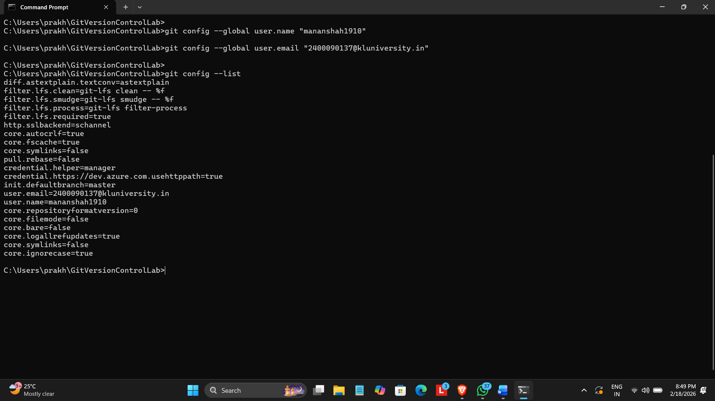Create two files (example: main.java, notes.txt) with sample content, check the repository status, and add them to staging.

Create files:
touch main.java touch notes.txt

Add sample content:
main.java

public class Main {
public static void main(String[] args) { System.out.println("Hello Git Version Control");
}
}

notes.txt
This project demonstrates Git version control basics.

Check repository status:
git status

Add files to staging:

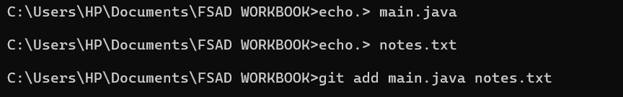
git add main.java notes.txt

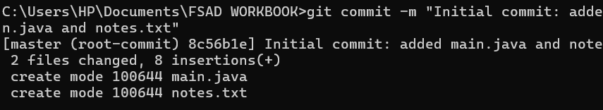
- Commit the staged files with a meaningful commit message.

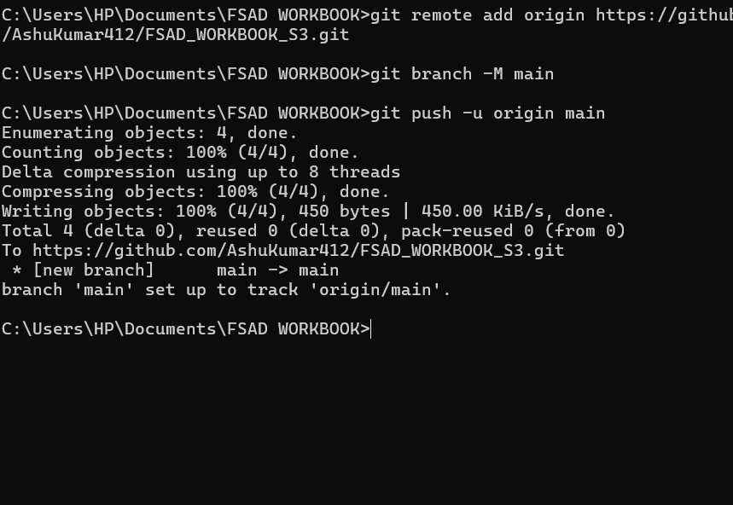
- Create a new repository on GitHub, connect your local repo using the remote URL and push the committed changes.

- Create the first branch (example: feature-update), make modifications, and add + commit
the changes.

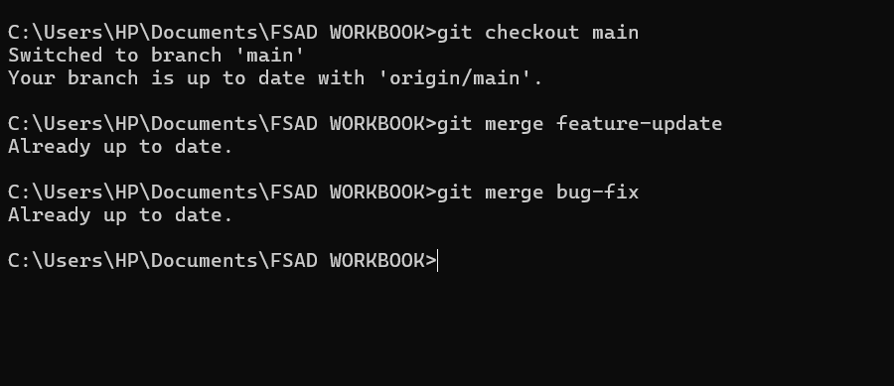

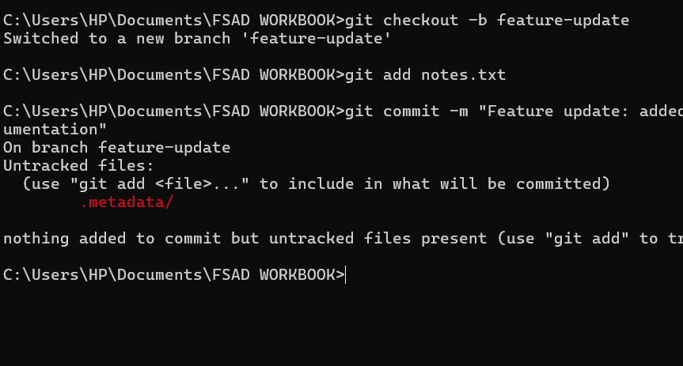
- Create a second branch (example: bug-fix), apply changes, and add + commit them.
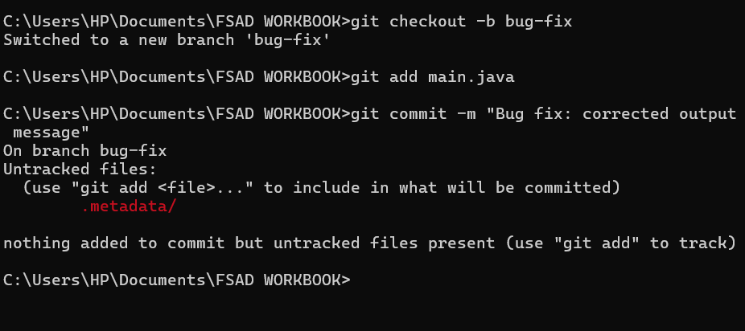

- Switch back to the main branch and merge both branches one after the other.

- If any merge conflict occurs, resolve it manually, commit the fix, and complete the merge.

f Git reports a conflict:
<<<<<<< HEAD
Old code
=======
New code
>>>>>>> branch-name
Steps to resolve:
- Open the conflicted file
- Manually correct the code
- Remove conflict markers
- Save the file
Complete merge:
git add .
git commit -m "Resolved merge conflict between branches"

Final Push to GitHub
git push origin main

VIVA QUESTIONS:

- Why is Git used in development?

Git is used in development to manage and track changes in source code.

Main reasons:
  - Keeps history of code changes
  - Allows multiple developers to work together
  - Helps in creating branches for new features
  - Makes it easy to undo mistakes
  - Supports collaboration using platforms like GitHub
In short: Git helps developers work safely, efficiently, and collaboratively.

- What information is stored in Git configuration?

Git configuration stores user and system settings used by Git.

Common information stored:
  - Username (author name)
  - Email address
  - Default editor
  - Default branch name
  - Merge and push behavior
  - Aliases for commands

Types of configuration:
  - System level – for all users
  - Global level – for one user
  - Local level – for one repository

Example:
git config --global user.name "AshuKumar412"
git config --global user.email "2400032678@kluniversity.in"

- What is Maven and why is it used?

Apache Maven is a build automation and project management tool mainly used for Java projects.

Why Maven is used:
  - Automatically manages project dependencies
  - Builds, tests, and packages applications
  - Maintains a standard project structure
  - Reduces manual work
  - Ensures consistent builds
In simple words: Maven makes Java project development faster and easier.

- What is the role of the POM.xml file?

OM.xml (Project Object Model) is the core configuration file of Maven.

It contains:
  - Project name and version
  - Dependencies (libraries)
  - Plugins
  - Build configuration
  - Packaging type (JAR, WAR)

Role:
  - Tells Maven how to build the project
  - Defines what libraries are required
  - Controls the complete build process

Without POM.xml, Maven cannot work.

- Explain Maven Build Life Cycle.

Maven Build Life Cycle is a sequence of steps used to build a project.

Main Maven Life Cycles:

- Default Life Cycle (Build) Used to create the application. Steps:
validate – checks project structure compile – compiles source code test – runs test cases
package – creates JAR/WAR file install – installs package in local repo deploy – deploys to remote repo

Clean Life Cycle
Used to clean old build files. clean – deletes target folder

Site Life Cycle
Used to generate documentation. site – creates project reports

Example Command:
mvn clean install
(This cleans old files and builds the project.)

(For Evaluator’s use only)

 | Comment of the Evaluator (if Any) |  | Evaluator’s Observation  Marks Secured: out of  EMP ID & Full Name of the Evaluator:  Signature of the Evaluator Date of Evaluation:

T E A M FS AD

